End-to-End FastAPI Workflow for US Stocks Data Analytics to Excel Using VBA/PowerQuery

Python Analytics

↓

FastAPI Endpoints

↓

JSON Response

↓

Cloud Deployment (Render)

↓

Excel VBA/PowerQuery HTTP Call

↓

Parsed Results in Excel

STEP 1: Develop Python Analysis Code and Integrate FastAPI

Objective:
Create the backend logic that performs analytics and exposes results through an API.

Process Overview:
- Develop Python analysis logic using Pandas
- Create a list of stock tickers to download data for
- Define upper and lower limits of date time objects to download the data for a time frame
- Fetch historical market data using yfinance
- Compute summary statistics
- Store results in a Pandas DataFrame
- Refactor analysis logic into a reusable Python function
- Create a FastAPI application object
- Define endpoints for FastAPI:
  - (/) for health check, used for quick validation after deployment, like displaying a message in our case “US Stock Analysis API is running”
  - (/summary) for returning analytics results data frame, used for actual computation of data, and returning the resultant data in JSON format

Outcome:
Python analytics are now accessible as a REST API returning JSON.

STEP 2: Organize the Project Structure

Objective:
Ensure the project is portable, deployable, and cloud-ready for which a proper structure of files should be maintained.

Project folder structure:
USStocksAnalysis_FastAPI/
├── main.py
├── requirements.txt
└── README.txt

Important Notes:
- Code must be saved as .py, not .ipynb

STEP 3: Define Dependencies and Test Locally

Objective:
Verify the API works correctly before deployment by testing it locally

requirements.txt content:
fastapi
uvicorn
pandas
numpy
yfinance

Note:
The requirements.txt file defines all external Python dependencies required for the application to run successfully. It acts as a single source of truth for the runtime environment. Any environment uses this file to recreate the exact software setup needed by the application. Hence, even a misspelled or missing dependency can cause failure in deployment.

Local testing steps:
- Open Command Prompt in project folder
- Install dependencies:
pip install -r requirements.txt
- Run the API:
uvicorn main:app --reload
- Validate in browser:
http://127.0.0.1:8000/summary

Outcome:

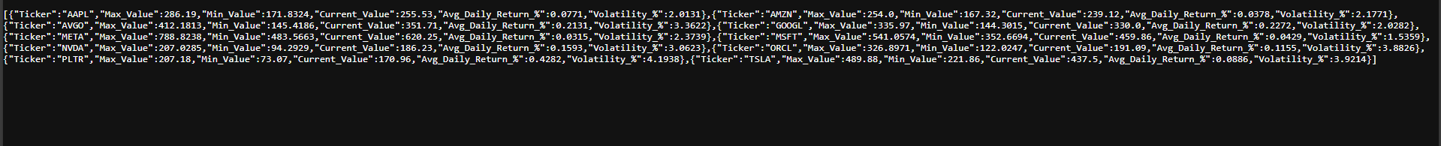
JSON output confirms FastAPI and analytics logic work locally.

STEP 4: Push the Project to GitHub

Objective:
Enable version control and prepare for cloud deployment.

Phase 1: Local GIT

Using Command Prompt:
# initialize a new git repository
git init

# stages all project files for next commit,(.) means include all
git add .

# Creates a snapshot (commit) of the staged files.
git commit -m "US Stocks FastAPI"

# Renames the current branch to main.
git branch -M main

Phase 2: Create GitHub Repository
- Login to GitHub Website
- Click New Repository
- Do NOT initialize with README/.gitignore/license
- Click New Repository
- GitHub will generate an URL for the repository

Phase 3: Link Local Repository to GitHub
Open command prompt in your project folder and add the exact URL instead of “<repo-url>” in the command shown below
# Links the local Git repository to a remote GitHub repository
git remote add origin <repo-url>

# Pushes the local main branch commits to GitHub.
git push -u origin main

Outcome:
Code is available on GitHub and ready for deployment.

STEP 5: Deploy the API on Render

Objective:
Host the FastAPI application on the cloud.

Create a New Web Service on Render:

Login to Render

Click New Web Service

Connect your GitHub account to Render

Select your newly created repository

Render configuration:
- Service type: Web Service
- Runtime: Python
- Build command:
- pip install -r requirements.txt
- Start command:
- uvicorn main:app --host 0.0.0.0 --port 10000

Validation:
- Check Render logs
- Access deployed endpoint:
- https://<app-name>.onrender.com/summary

Outcome: The API is live and publicly accesible

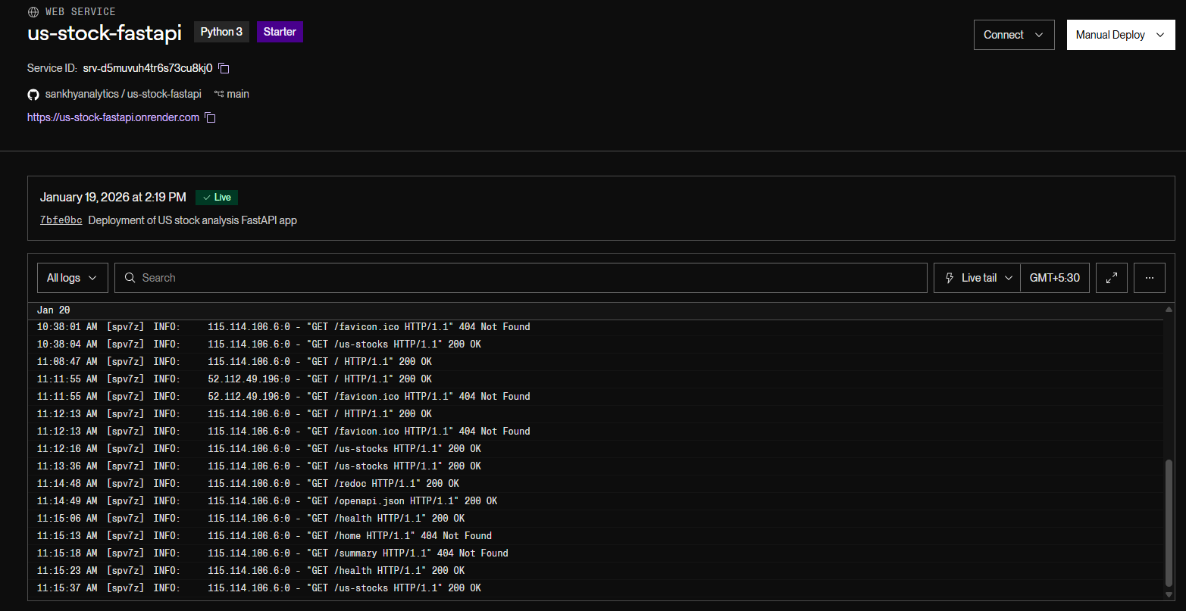

STEP 6: Integrate Excel Using VBA/PowerQuery

6A : Using VBA

Objective:
Consume the API output in Excel and display results dynamically.
Process Overview:

(1) Prepare the Excel File
- Open Excel and create a new blank workbook
- Save the file as:
USStocks_API_Dashboard.xlsm
- File type must be Excel Macro-Enabled Workbook (.xlsm)
- Macros do not run in .xlsx files

(2) Open the VBA Editor
- Press ALT + F11 for launching VBA Editor

(3) Enable Required VBA Reference
- In VBA Editor:
Tools → References
- Enable Microsoft Scripting Runtime
- Click OK
This is required for dictionary objects used in JSON parsing.

(4) Add JSON Parsing Capability
- Download JsonConverter.bas from:
- https://github.com/VBA-tools/VBA-JSON

(5) Import JSON Parser
- In VBA Editor:
File → Import File
- Select JsonConverter.bas
- Verify that JsonConverter appears under Modules in Project Explorer
Without this module, JSON responses cannot be processed.

(6) Add the VBA Module
- In VBA Editor:
Insert → Module
- A new module (e.g., Module1) is created
- This module is stored internally within the Excel file
(7) Write API Integration Code
- Paste the VBA macro that:
  - Sends an HTTP request to the FastAPI /summary endpoint
  - Receives JSON response
  - Clears existing worksheet data
  - Writes headers and populates rows dynamically
Note: The API URL must point to the deployed Render application.

(8): Compile the Project
- In VBA Editor:
Debug → Compile VBAProject
- If no errors appear, the code is valid

(9) Return to Excel
- Press ALT + Q or close the VBA Editor

(10) Enable Developer Tab (if not visible)
- File → Options → Customize Ribbon
- Enable Developer
(11) Insert Button
- Developer tab → Insert → Button (Form Control)
- Draw the button on the worksheet
(12) Assign Macro
- Assign the macro RefreshUSStockSummary to the button
Where, RefreshUSStockSummary = sub procedure defined in VBA code
(13) Rename Button
- Rename the button to:
Generate US Stock Summary

(14) Execute the Workflow
- Open the .xlsm file
- Enable macros
- Click the button

Outcome:
Excel functions as a frontend client with one-click data refresh

6B : Using PowerQuery
- Open Power Query
- Go to Data tab
- Click Get Data → From Other Sources → From Web
- Enter API URL
  - Paste your API link:
  - https://your-app.onrender.com/us-stocks
  - Click OK
  - Choose Anonymous authentication (if asked)
- Convert JSON List to Table
- You will see List
- Click on Transform → To Table
- Click OK
- Expand Records into Columns
You’ll see a column like Column1 (Record)
- Click the expand icon (⤢) on the column header
- Select:
- Ticker
- Max_Value
- Min_Value
- Current_Value
- Avg_Daily_Return_%
- Volatility_%
- Click OK
- Load Data into Excel
- Click Close & Load
- Data will appear as a table in Excel

